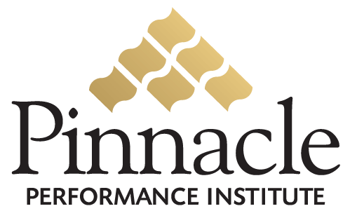

Pinnacle Development Membership

Pinnacle will provide a Free Development Membership for each user at no charge to them. The Company will be billed a nominal amount for each active account per month. An account is considered active if it has been accessed within the previous 90 days. The Company is not billed for any accounts that are never accessed. A deposit is required and will be applied toward future Development Membership fees.

The new and existing users will be added to the Company’s customized performance platform for a Free Development Membership via an automated system interface provided by Pinnacle.

The following summary identifies the benefits of the Free Development memberships and the Paid Performance Memberships.

FREE DEVELOPMENT MEMBERSHIP
- Self-help Assessments (professional & personal development, Stephen Covey 7 Habits, Behavioral Profiles, etc.)
- Certifications (company qualified tests on product knowledge, policies & procedures, sales skills, etc.)
- Electronic Suggestion Boxes (facilitate ideas from the field)
- Dynamic Surveys (company customized polling of users)
- Goal Management Program (track performance variances of individual and company prescribed goals)
- Mentoring Program (ability to be mentored by an experienced leader)

PAID PERFORMANCE MEMBERSHIP (not included in the Development Membership)
- Online Interactive Multimedia Training Courses (company specific and Fortune 500 corporate training)
- Online Conference Rooms (real-time interaction)
- Online Discussion Boards (archived discussions)
- Support Search Engine (support documents and questions & answers)
- Leadership Mentoring (ability to mentor others)

